

**Main Access User Manual**

**Version 2.1**



Table of Contents

1. Introduction to Lease-Desk: 4

2. Logging into Lease-Desk: 5

3. Home Screen: Adding, Editing, Viewing & Deleting 6

3.1. Adding, Editing, Setting as Main, and Deleting Addresses: 7

3.1.1. Adding an Address: 7

3.1.2. Editing an Address: 8

3.1.3. Setting an Address as Main: 9

3.1.4. Deleting an Address: 10

3.2. Adding, Viewing, and Deleting Files: 11

3.2.1. Adding a File: 11

3.2.2. Viewing a File: 12

3.2.3. Deleting a File: 13

3.3. Providers: Associating and Deleting Association: 13

3.3.1. Associating a Provider (Vendor Only): 13

3.3.2. Deleting a Provider Association (Vendor Only): 14

3.4. Adding, Editing and Deleting Products (Vendor Only): 15

3.4.1 Adding a Product: 15

3.4.2 Editing a Product: 16

3.4.3 Deleting a Product: 16

4. Agreements Screen: Viewing, Adding Notes, and Viewing Audit Log 17

4.1.1 Calling or Emailing a Primary Contact: 19

4.1.2 Creating Follow Ups………………………………………………………………………………………………………………..21

4.1.3 Adding, Viewing and Deleting a File: 23

4.1.4 Viewing a Note: 23

4.1.5 Adding a Note: 24

4.1.6 Editing a Note………………………………………………………………………………………………………………………….24

4.1.7 Deleting a Note……………………………………………………………………………………………………………………….24

4.1.8 Summarising Notes…………………………………………………………………………………………………………………25

4.2. Viewing an Audit Log: 26

5.0 Search: 27

5.1. Searching for Specific Customer Agreement Information: 29

5.2. Searching for all Customer Agreement Information: 32

5.3 Changing the Search Mode………………………………………………………………………………………………………..33

5.3.1 Secondary Rental Report…………………………………………………………………………………………………………33

5.3.2 Forecast Secondary Report……………………………………………………………………………………………………..34

6. Dashboard: 34

6.1. Prospects: 35

6.1.1 Viewing Top Prospect Information in Graphical Format: 36

6.2. Customers: 37

6.2.1 Viewing/Amending Portfolio Information: 39

7. Alerts: 41

8. General Functionality: 44

8.1. Sort: 44

8.3 Refresh: 45

8.4 Scrolling through records: 45

8.5 Changing the amount of records per view: 45

8.6 Last 10 Records: 46

9. Feedback: 46

10. Frequently Asked Questions: 48

11. Contact Details: 49

# 1. Introduction to Lease-Desk:

Lease-Desk is a Portfolio Management System designed specifically by Proctor Consulting, which provides a dedicated platform for Vendors to view and manage all current and pending Customer Agreements in one place.

Once the existing Vendor data has been uploaded by Proctor Consulting’s Lease-Desk Administration team, main access users are able to view and/or edit their individual or teams current pending or live customer agreements, and view an overall snapshot of all current agreements via the dashboard. All available repeat business opportunities are indicated via the dashboard functionality so that users can view all leasing activity, making it easier to manage and ensure no repeat business opportunity gets missed again.

In addition, email notifications are sent to relevant Individuals, Teams and Management relating to end of term actions so that no action is missed, helping to increase customer retention and increase customer satisfaction by being able to continually offer support and advice and assist customer requirements both now and in the future.

The following user guide is aimed at all ‘Main’ Access Users who have been set up with a Lease-Desk Account. As a Main user you will generally have ‘reader’ access rights to the groups that you have been set up in by the administrators. This means that you can view all of the live and pending agreement information for all writers within the groups you are in.

The terminology for all role types is defined below;

* **Reader:** You can read (or view) all of the live and pending agreement information for the groups that you are in.
* **Writer:** You can view all of your agreements that you are associated with however you will not see any other member’s agreement information.
* **Reader/Writer:** You can view the live or pending agreement information for the teams that you are in and also add agreement information to the groups that you are in.

# 2. Logging into Lease-Desk:

1. Go to [www.Lease-Desk.com](http://www.Lease-Desk.com) and click on the Client Login box as per below.

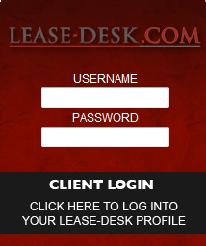

2. You will then be presented with the User Login page, as per below.

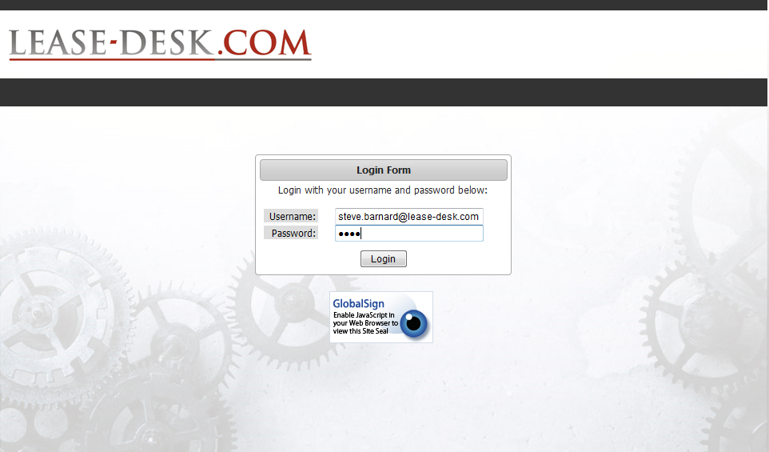

3. Enter your details and click on 

4. To Log Out, select **‘Logout’** from the top menu screen.

# 3. Home Screen: Adding, Editing, Viewing & Deleting

1. Once you have logged in you will be presented with the home screen, as per below;

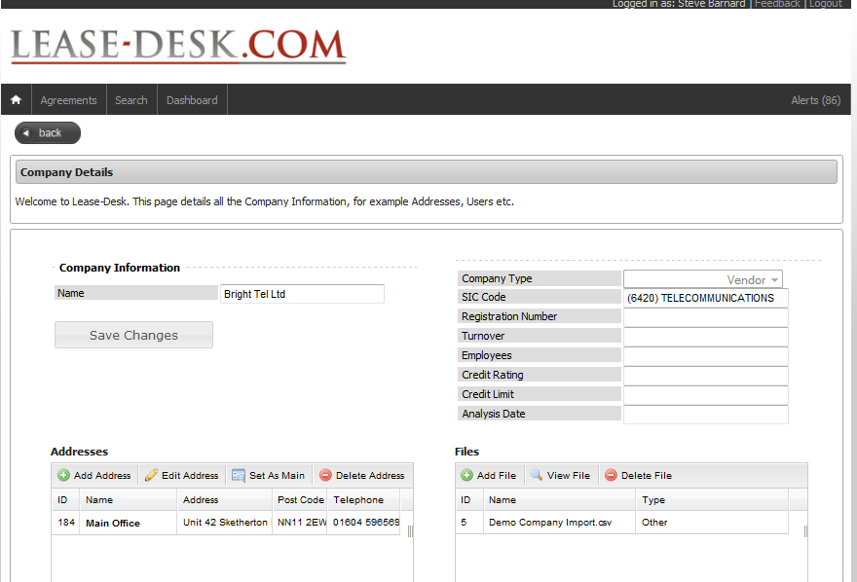

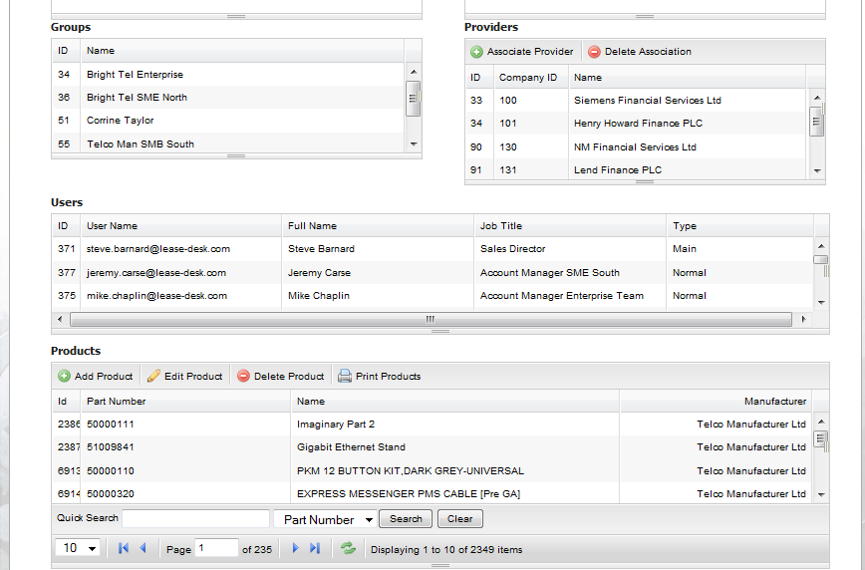

2. This screen details information relating to your company such as Addresses, Files, Users, Products and Providers, (if you are a Vendor), Groups (if you are a Vendor) and Financial Products (if you are a Financial Provider).

## 3.1. Adding, Editing, Setting as Main, and Deleting Addresses:

### 3.1.1. Adding an Address:

1. Click on  from the main Addresses table as indicated below.

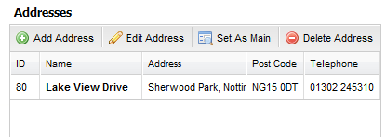

2. You will then be presented with the following ‘Add an Address to Company’ screen;

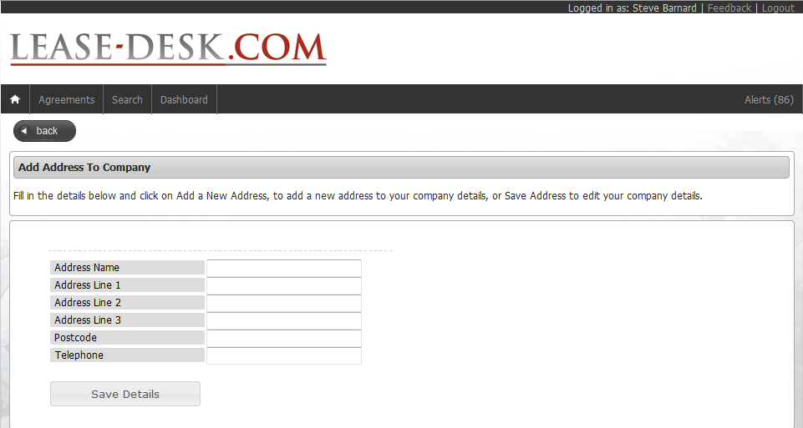

3. Fill in the full address details and click on 

4. You will then be taken back to your Company Details screen in Edit mode and be presented with the following confirmation message;



5. The address will also appear within the ‘Addresses Table’ as per below;

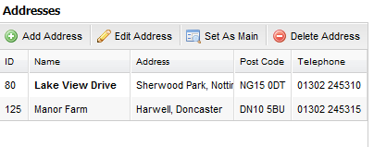

# 3.1.2. Editing an Address:

1. From the main Addresses table, highlight the required address as indicated below;

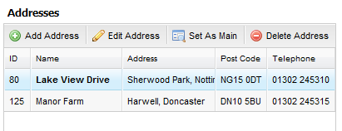

2. Click on 

3. You will then be presented with the ‘Edit Address’ screen as indicated below;

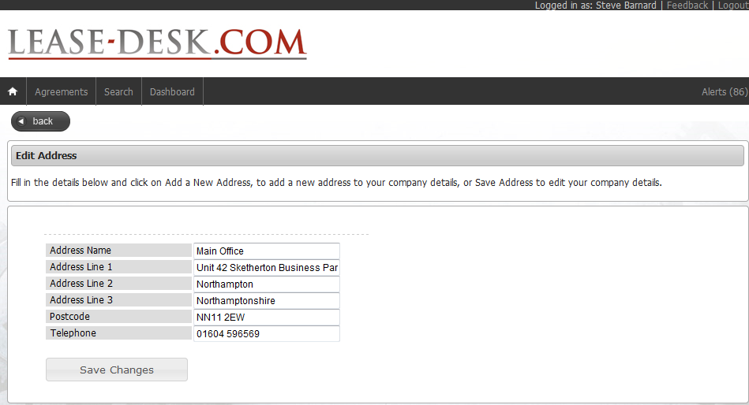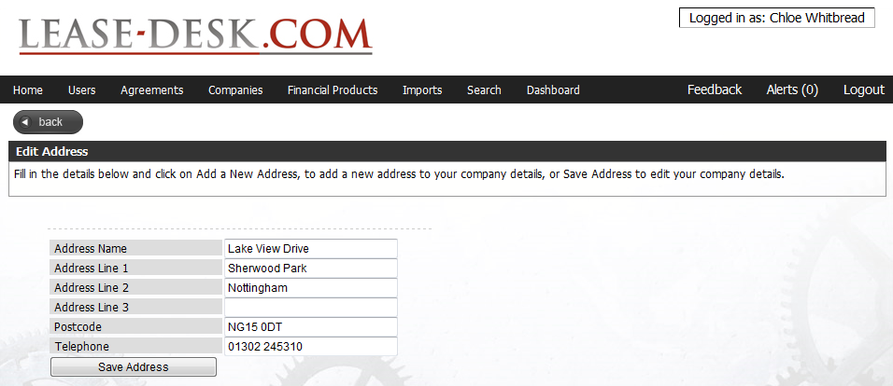

4. Amend the required Address details and click on 

5. You will then be presented with the following confirmation message and taken back to your main Company Details screen, in Edit mode.



### 3.1.3. Setting an Address as Main:

1. To set an address against your Company Details as the main site address, highlight the required address (as indicated previously) and click

2. You will then be presented with the following confirmation message;



3. The main site address will also be highlighted in bold within the Addresses table,

as indicated below;

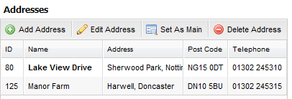

# 3.1.4. Deleting an Address:

1. To delete an address from your Company Details, highlight the required address (as indicated previously) and click

2. You will then receive the following message;

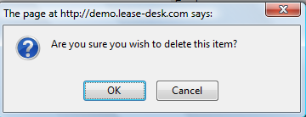

3. Click OK to delete (or Cancel to cancel the action).

4. Once you have confirmed deletion is required you will be presented with the following message and taken back to the Edit Company Details screen;



# 3.2. Adding, Viewing, and Deleting Files:

**Please Note: You will need Adobe Reader installed for Adding and Viewing Files.**

# 3.2.1. Adding a File:

1. Go to the Files table within the homepage, as indicated below;

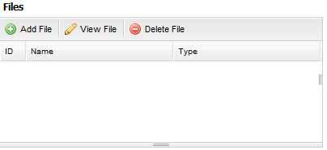

2. To add a file against your Company Details, click 

3. You will then be presented with the ‘Add a New File’ screen as indicated below;

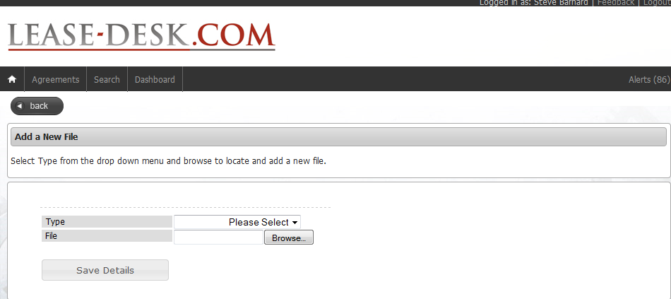

4. Select a ‘Type’ from the drop down menu, for example Credit Report, Management Accounts etc.

5. Click within the ‘File’ box and click on ‘Browse’ to look for the saved file from your PC, as indicated below;

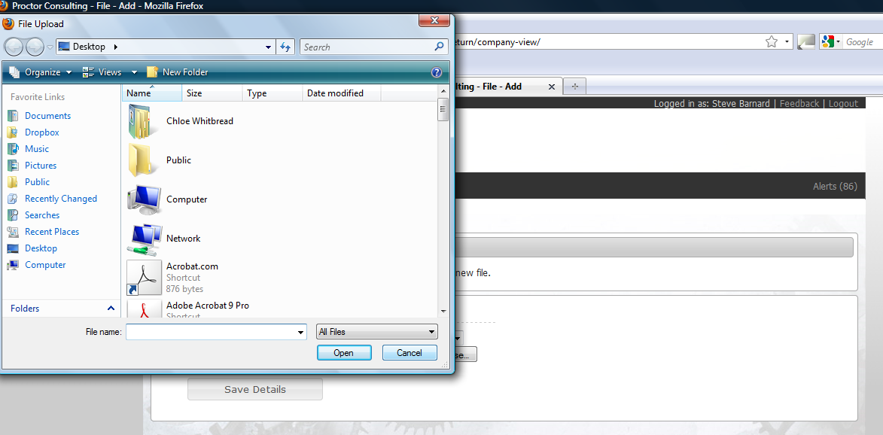

6. To save the file against your Company Details, click

7. You will then be taken back to the ‘Edit Company Details’ screen and receive the following confirmation message;



# 3.2.2. Viewing a File:

1. To view an existing file against your Company Details, go to the Files table within the homepage, as indicated previously, and highlight file required.

2. Click 

# 3.2.3. Deleting a File:

1. To delete a file against your Company Details, go to the Files table within the homepage, as indicated previously, and highlight file required.

2. Click 

3. You will then be presented with the following pop up screen;



4. Click on OK to delete (or Cancel to cancel action).

5. You are then taken back to the Edit Company Details screen where you will receive the following confirmation message;



# 3.3. Providers: Associating and Deleting Association:

# 3.3.1. Associating a Provider (Vendor Only):

1. To associate a Provider with your Company, go to the Providers table, within the Edit

Company Details screen;

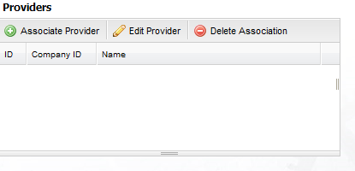

2. Click 

3. You will then be presented with the ‘Add a Provider’ screen as per below;

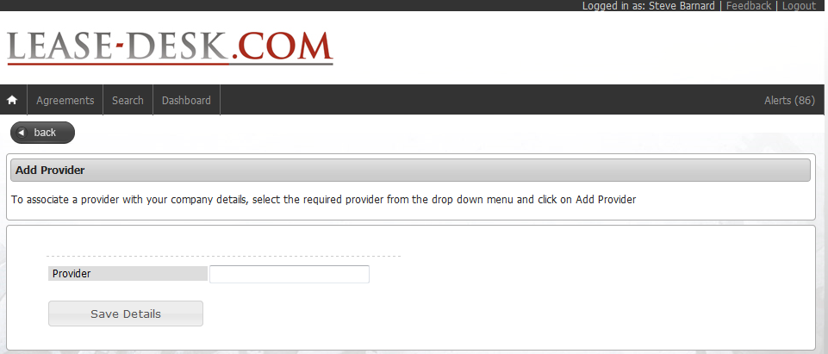

4. Select a Provider from the drop down menu and click 

5. You will then be taken back to your homepage.

# 3.3.2. Deleting a Provider Association (Vendor Only):

1. To delete an associated Providers details, go to the Providers table, within the Edit

Company Details screen as previously shown and highlight the required Provider.

2. Click 

3. You will then be presented with the Confirmation Message as per below. Select OK to delete or Cancel to cancel action.

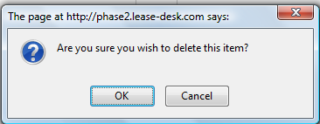

4. You will then be taken back to your home screen.

# 3.4. Adding, Editing and Deleting Products (Vendor Only):

# 3.4.1 Adding a Product:

1. To add a Product to your Company Details, go to the main Products table within the homepage as indicated below;

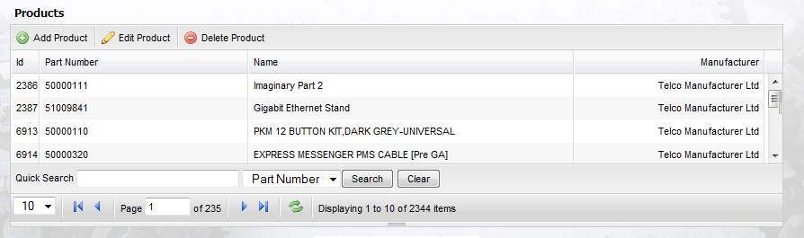

2. Click 

3. You will then be presented with the ‘Add a New Product’ screen as indicated below;

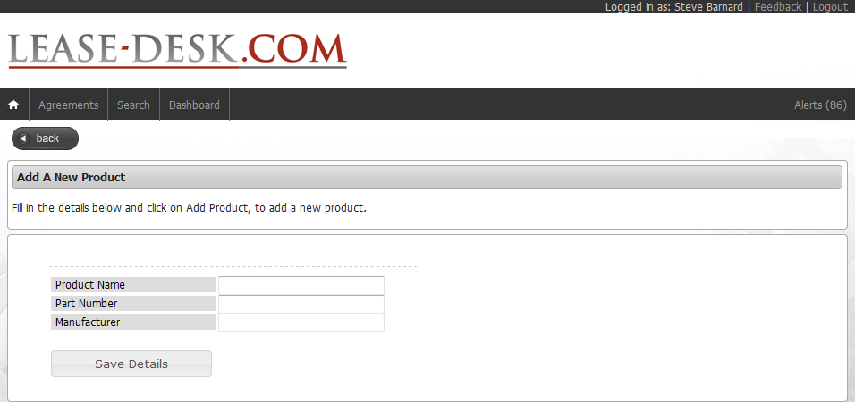

4. Fill in the details and click 

5. You will then be taken back to the main Company Details screen and receive the following confirmation;



# 3.4.2 Editing a Product:

1. To edit an existing Product against your Company Details, go to the main Products table within the homepage as indicated previously and highlight the required product from the list.

2. Click 

3. You will then be presented with the ‘Edit Product Details’ screen as per below;

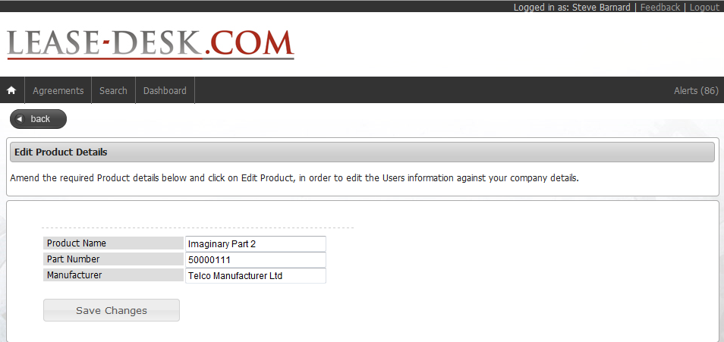

4. Amend the required detail and then click 

5. You will then be taken back to the Company Details screen and will receive the following confirmation message;



# 3.4.3 Deleting a Product:

1. To delete an existing Product against your Company Details, go to the main Products table within the homepage as indicated previously and highlight the required product from the list.

2. Click 

3. You will be presented with a confirmation pop up. Click OK to continue with the deletion or Cancel to cancel the action.

4. Once deleted you will be taken back to the Company Details screen and presented with the following confirmation message;



**Note: You will be unable to delete a product if the chosen product is associated with one or more Agreements.**

# 4. Agreements Screen: Viewing, Adding Notes, and Viewing Audit Log

**4.1. Viewing a Live or Prospect Agreement:**

1. From the top toolbar menu, select 

2. You will then be presented with all of the live and prospect agreements for which you are either associated with, or are able to view due to your role status, i.e. Reader or Reader/Writer (Refer to Chapter 1: Introduction to Lease-Desk for further information).

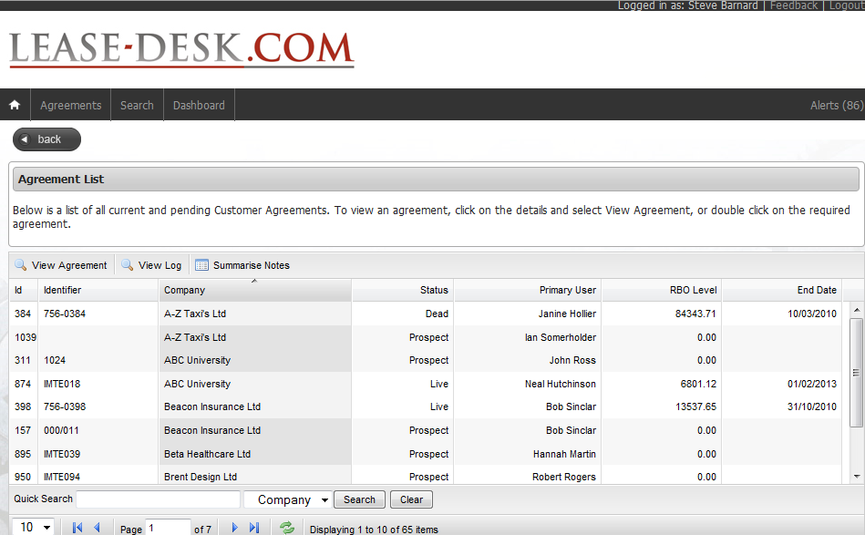

3. Highlight the required Agreement from the main Agreement Lists screen.

4. Click  or double click with your mouse on the agreement required.

5. You will then be presented with the full ‘View Agreement Details’ screen. This is

indicated on the following page).

**Companies Information:**

This lists all of the companies associated with the agreement, i.e. end Customer, Vendor and Finance Provider along with the Primary Contact for each.

**Customer Information:**

This indicates the Credit Limit, Credit Rating and Analysis Date for the end Customer, all of which is taken from Credit Safe UK.

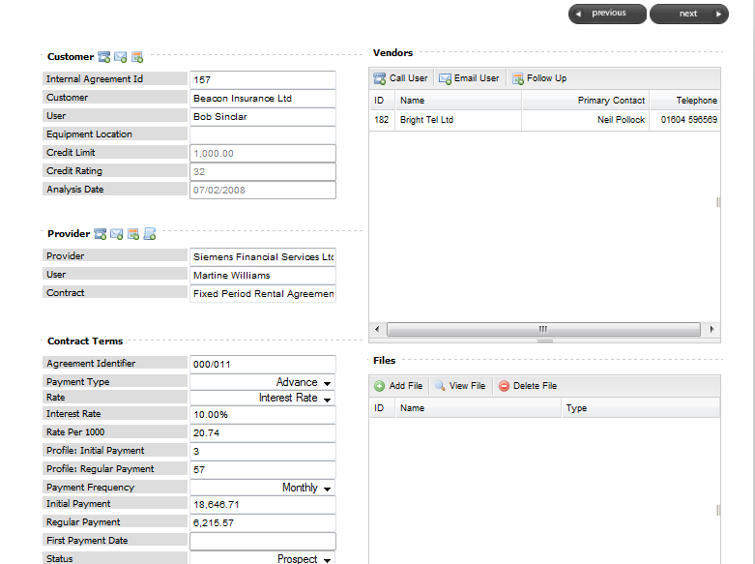

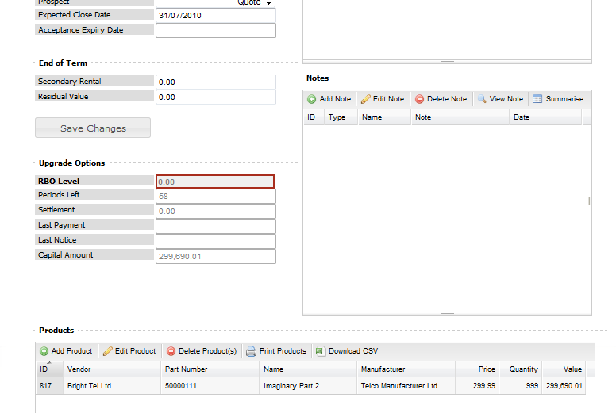

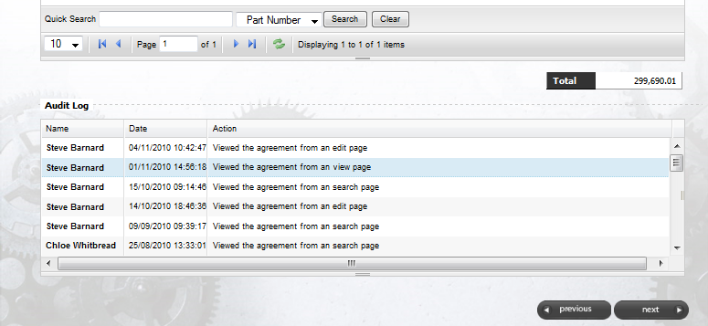

**Contract Terms:**

This lists all of the contractual information taken from the Providers T’s and C’s within the Agreement.

The Status shows whether it is a live deal or a Prospect and indicates where the Prospect is within the sales process.

**Financial Product Information:**

This details the Financial Product information

**Upgrade Options:**

The RBO (Repeat Business Opportunity) level indicated shows how much a customer has to spend on technology refresh. **Note this is only available on live deals**

# 

**End of Term:**

Indicates whether the Financial Product carries secondary rentals and if so what the figure would be.

**Product Information:**

This lists the Product (s) within the agreement.

# 4.1.1 Calling or Emailing a Primary Contact:

**4.1.1 Calling or Emailing a Primary Contact:**

1. Within the Companies table, highlight the required user and then click on the required

 Option;

1. If you have selected the ‘Call User’ option, you will then be presented with the screen below

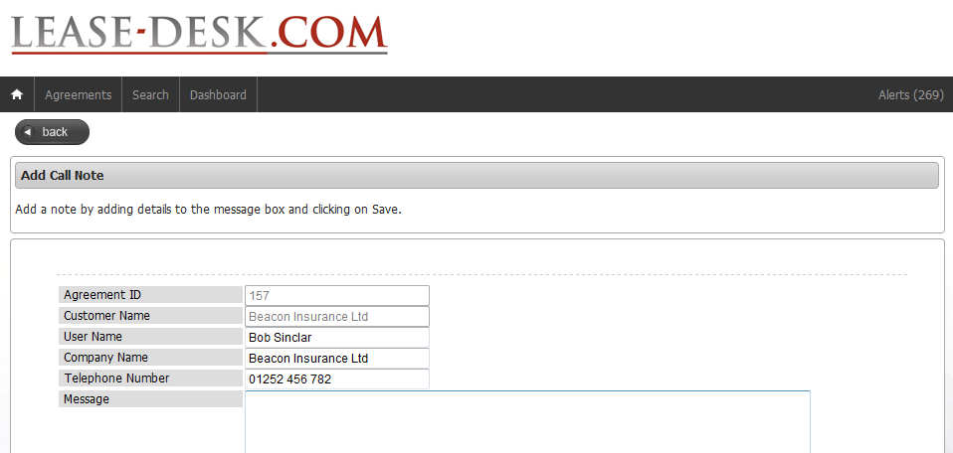

1. Complete the details and click 
2. The detail will then be saved as a standard note, visible within the agreement.

# If you have selected the ‘Email User’ option, you will then be presented with the

following screen;

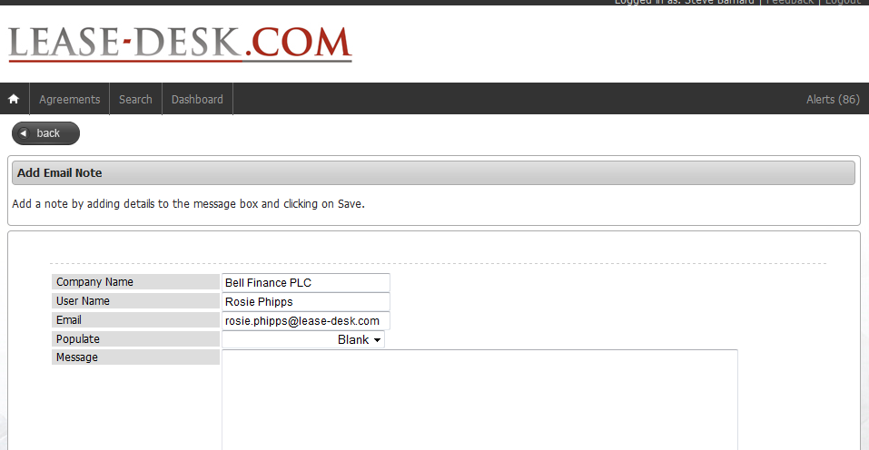

# 6. Select either ‘Blank’ or ‘Agreement Details’ from the ‘Populate’ dropdown list.

# 7. Enter the message and either click on ‘Save’, to save the message or ‘Open in

Email Client’ to open up your email ready to send the message inputted.

**4.1.2 Creating Follow Ups:**

1. Highlight the contact required from the Companies table as indicated below;

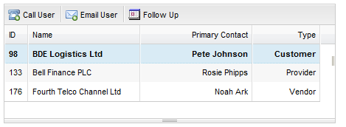

2. Click on 

3. You will then be presented with the following screen;

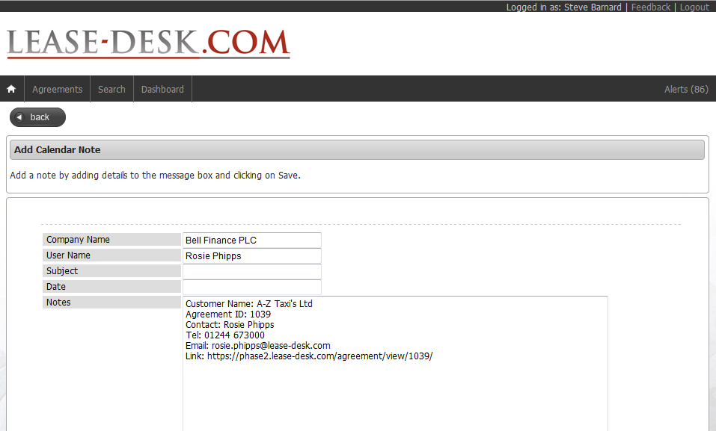

4. Enter a ‘Subject’ line and then click in the ‘Date’ box to bring up a calendar.

5. Set the date and time for the follow up and then enter any other details into the ‘notes’ box.

6. Click  to open up your email and click to save.

7. You will then be presented with the following pop up;

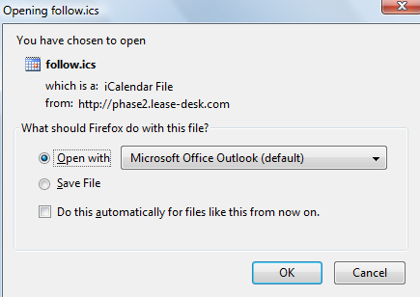

8. Click on ‘Ok’ to open up your email. You will then receive the following screen;

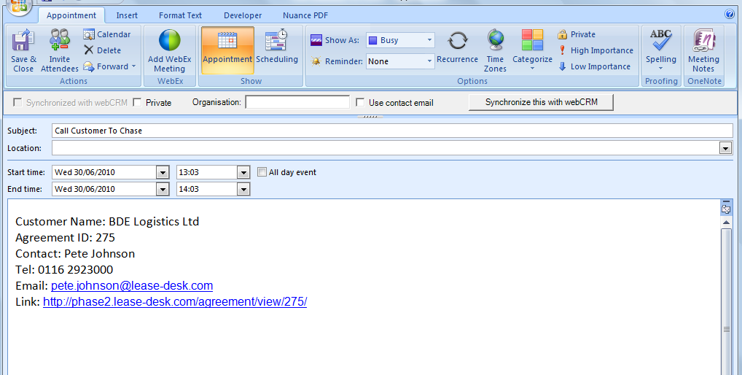

9. Click ‘Save & Close’ to then add to your outlook calendar as a reminder.

# 4.1.3 Adding, Viewing and Deleting a File:

1. To Add, View or Delete a File, follow chapter **3.2. Adding, Viewing and Deleting Files**

# 4.1.4 Viewing a Note:

1. Within the main ‘View Agreement’ screen, go to the Notes table as indicated below;

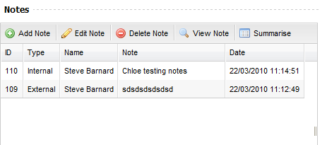

1. Click 
2. You will then be presented with the ‘View a Note’ screen which will provide all details of which user added the note and when, as indicated below;

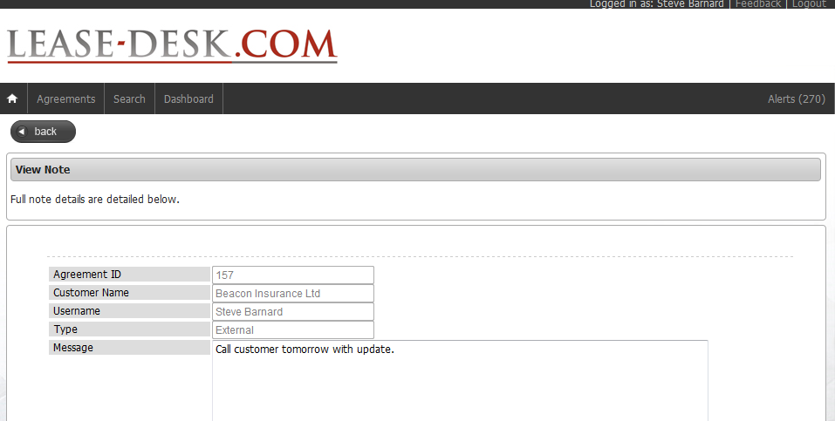

# 4.1.5 Adding a Note:

1. Within the main ‘View Agreement’ screen, go to the Notes table.



2. Click

3. You will then be presented with the following ‘Add Note’ screen;

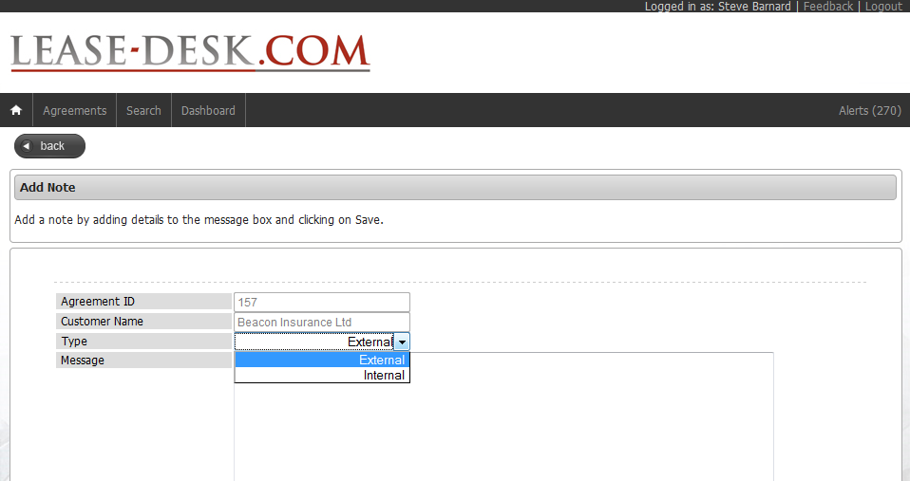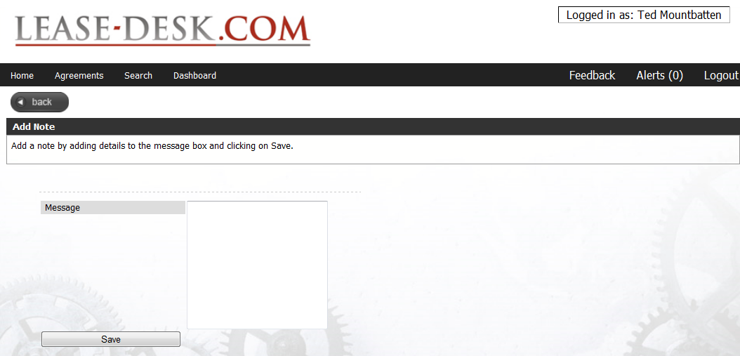

3. Select the Type, i.e. Internal or External.

**Note: An External note will generate an email to all users that can view the particular agreement and can be seen by everyone. An internal note can only be viewed by the users that can view the particular agreement within the particular user’s organisation.**

4. Type your message into the blank box

5. Click 

5. You will then be taken back to the main ‘View Agreement’ screen.

**4.1.6 Editing a Note**

1. Within the main ‘View Agreement’ screen, go to the Notes table.

2. Highlight the required note and click 

3. You will then be presented with the following ‘Edit Note Details’ screen;

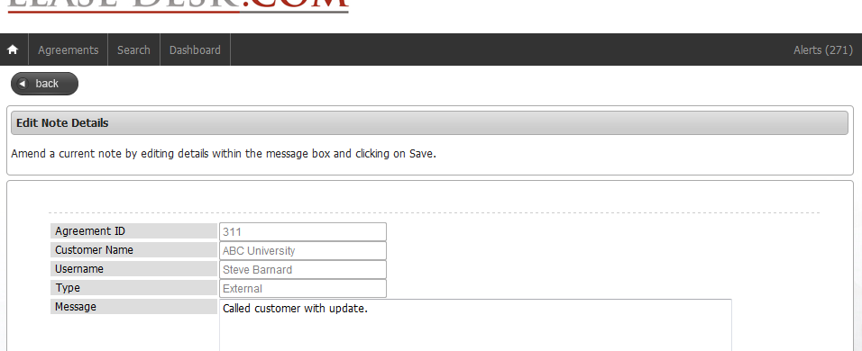

4. Amend the note as required and then click 

**4.1.7 Deleting a Note:**

1. Within the main ‘View Agreement’ screen, go to the Notes table.

2. Highlight the required note and click on 

3. You will then be presented with the following confirmation message;

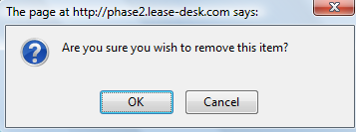

4. Select ‘OK’ to delete or ‘Cancel’ to cancel the request.

**4.1.8 Summarising Notes:**

1. You can view the Summarise Notes screen either within the particular agreement selected or via the main agreement list by highlighting the particular agreement and selecting:



2. You will then be presented with the following View Summarised Notes screen;

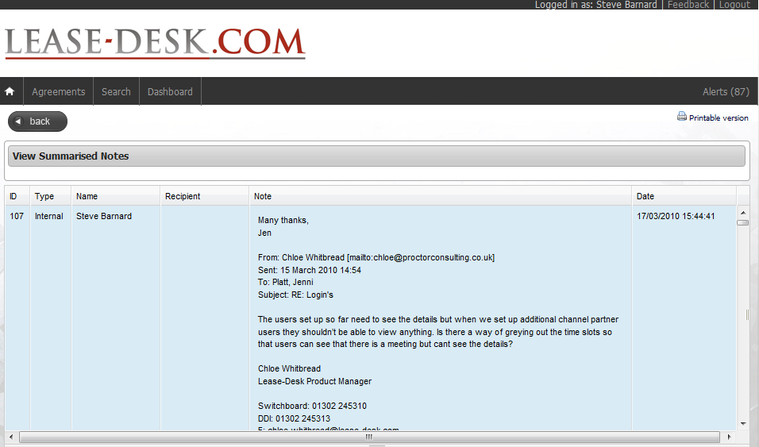

# 4.2. Viewing an Audit Log:

1. There are two ways in which to view the Audit Log against an agreement;

A) Either highlight the required Agreement from the main Agreement Lists screen as indicated previously and then click  to receive the following screen;

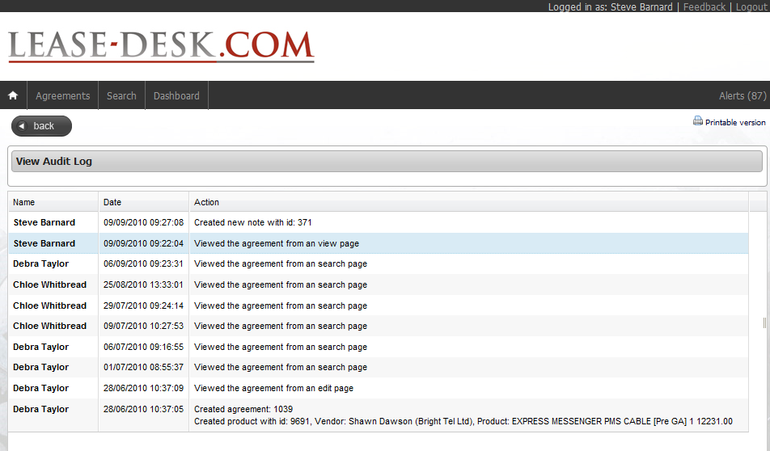

or

B) Select the Agreement required from the Agreement list and click and then scroll down to the bottom of the page where it says ‘Audit Log’ to be presented with the following;

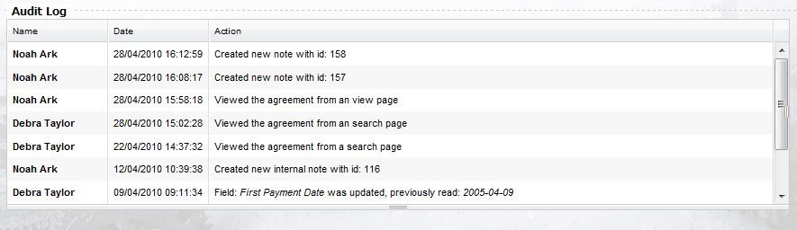

1. You will then be presented with the ‘View Audit Log’ screen which details all user actions against the selected Agreement, as detailed below;

**Note: Either way will show you the same information. It keeps a log of all activity against agreements such as when something is changed or when a user views an agreement either directly or via the Search screen. The system will only count one view per user, from any location per day in order.**

# 5.0 Search:

* 1. Go to  on the top main menu.
  2. You will be presented with the ‘Search Agreements’ screen as indicated on the following page in two parts;

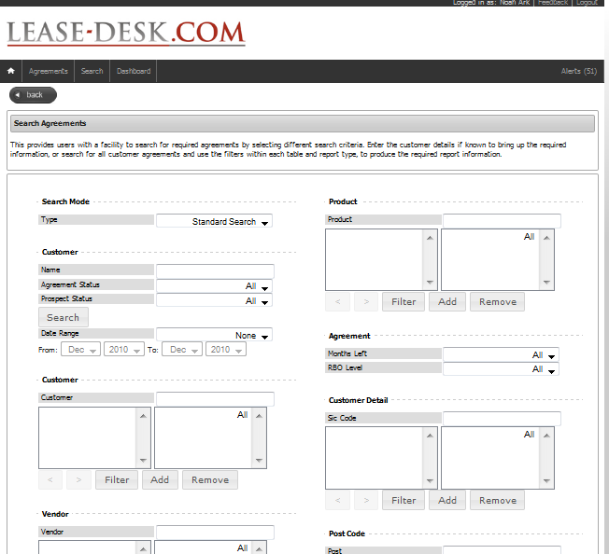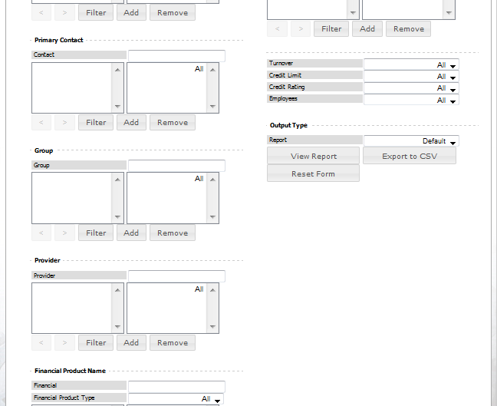

* 1. The Search Agreements screen, allows you to search for all agreement information, that you have access to (determined by role type), by using the different filters.
  2. To bring up the information in any of the tables, click 
  3. To remove any data selected, click 

## 5.1. Searching for Specific Customer Agreement Information:

1. From the main ‘Search Agreements’ screen as indicated previously, enter the full or first few letters of the company name you are looking for, as per below, keeping the standard search dropdown option.

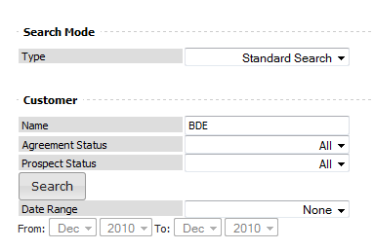

2. Complete the following details if required/known or keep as All;

* Agreement Status
* Prospect Status (if previous Status is set to Prospect)
* Date Range (if applicable). Note you can search for different options within this menu such as ‘Expected Close Date, Last Payment Date etc’.

3. Click 

4. The company agreement information relating to the inputted information will then be displayed in each of the filter tables, as indicated in the example below;

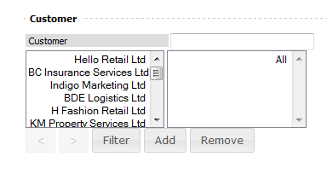

To include any of the produced data, within each table, in your search, highlight the required data, i.e. Primary Contact, and then click 

6. The data will then be moved into the second box as indicated below;

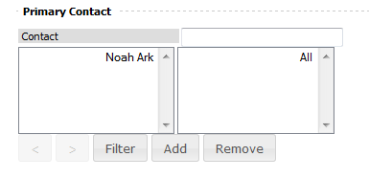

7. Carry on with each table required, following the previous step.

8. You will reach the following drop down options at the bottom of the search screen. If required, select an option from each;

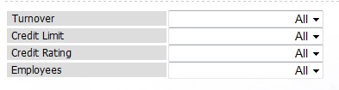

9. Go to the ‘Output Type’, and select a report type from the drop down menu.

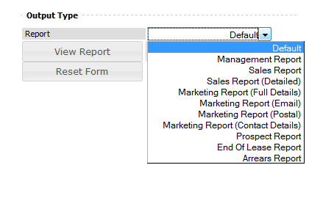

**Note: There are eleven different report types available, all of which provide different detailed information. These are broken down below;**

1. **Default:** ID, Identifier, Company, Status, Primary User, RBO Level, End Date

2. **Management Report:** Customer Name, RBO Level and Internal Agreement ID, Primary Vendor.

3. **Sales Report:** Vendor, Vendor Contact, Customer, Customer Contact, Customer Telephone, Postcode, Agreement ID, RBO Level, Term, Periods Remaining.

4. **Sales Report (Detailed):** ID, Agreement Status, Customer Name, Equipment location, Provider Name, External ID, Term, Regular Payment, RBO Level, Settlement Figure, Months Remaining & Capital Amount.

5. **Marketing Report (Full Details):** With all details listed below.

6. **Marketing Report (Email):** Customer Name, Primary Vendor, SIC Code, Turnover, Postcode, Primary Customer Contact, Primary Vendor, Primary Customer Email.

7. **Marketing Report (Postal):** As above, minus email but with full address details.

8. **Marketing Report (Contact Details):** As above, minus address but with Phone Number. Go to the ‘Output Type’, and select a report type from the drop down menu.

9. **Prospect Report:** Customer Name, ID, Prospect Status, Primary Vendor, Vendor User, Capital Amount.

10. **End of Lease Report:** ID, Customer Name, Term Type, Put Option, Put Option Cost, Secondary Rental, Secondary Rental Split, Notice Period, Last Payment Date.

11. **Arrears Report:** ID, Customer Name, Arrears Total, Settlement Figure,

10. Once the report type has been selected, click on 

and you will be presented with the data in the below format;

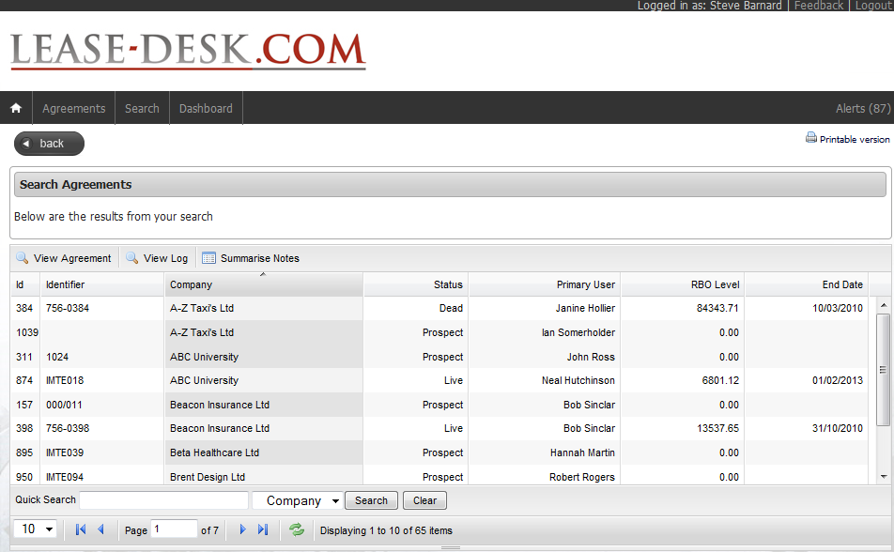

or  to view in CSV format as per below;

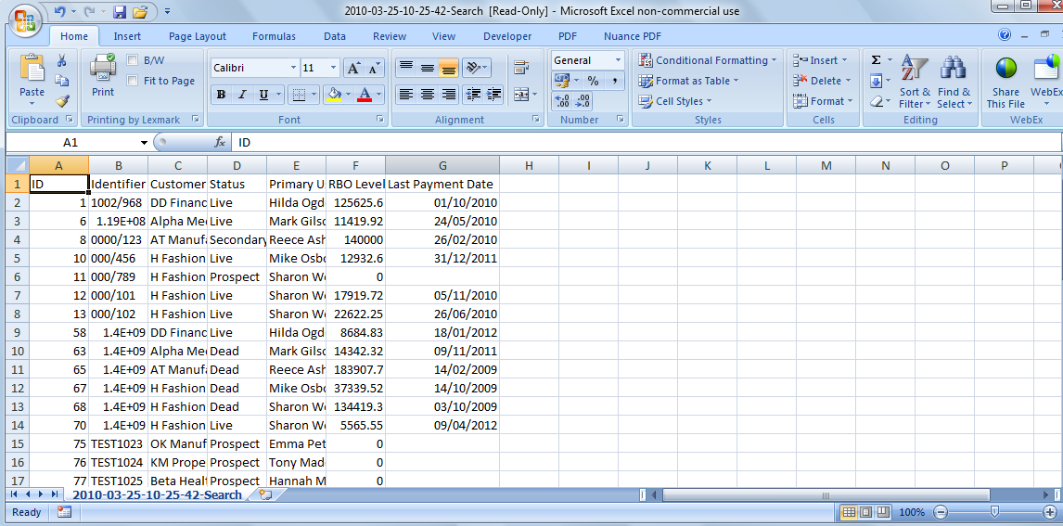

## 5.2. Searching for all Customer Agreement Information:

1. From the main ‘Search Agreements’ screen as indicated previously, leave the Customer name, field blank and Status and Prospect Status set to ‘All’

2. Click 

3. As indicated in previous steps, select any of the information using filters or leave as ‘All’.

4. Follow the previous step 9 on how to select report type and view data.

**5.3. Changing the Search Mode:**

1. On the main search screen you have the option to change the search mode in order to view two additional report types, as indicated below;

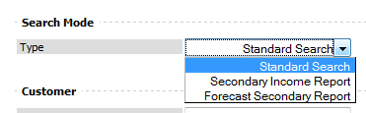

**5.3.1 Secondary Income Report**

1. If you select this report, it will automatically set the agreement status to ‘secondary period’ and Prospect Status to ‘All’.

2. Next, select the date range that you wish to search for, as indicated below.

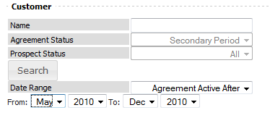

3. Continue to select the relevant criteria required before selecting your report type from the dropdown list.

4. Note: This report type is only viewable via CSV format. To view the data, click on as indicated below;

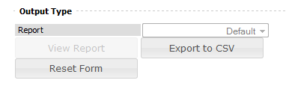

**5.3.2 Forecast Secondary Report**

1. If you select this report, it will automatically set the agreement status to ‘Live’ and Prospect Status to ‘All’.

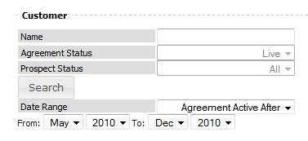

2. Next, select the date range that you wish to search for, as indicated below.

3. Continue to select the relevant criteria required before selecting your report type from the dropdown list.

4. Note: This report type is only viewable via CSV format. To view the data, click on as indicated below;



# 6. Dashboard:

This screen provides users with a snap shot of all organisational Live and Prospect agreement information determined by role type.

# 6.1. Prospects:

**Note*:*** This page will produce a table when data is available by filtering with prospect type

and grouping (user, group or Company).

1. Go to  on the main top menu.

2. You will automatically be presented with the default ‘Prospect’ page, which includes Prospects by Company, Prospects by Group and Prospects by User, and a graph showing all figures, as indicated below;

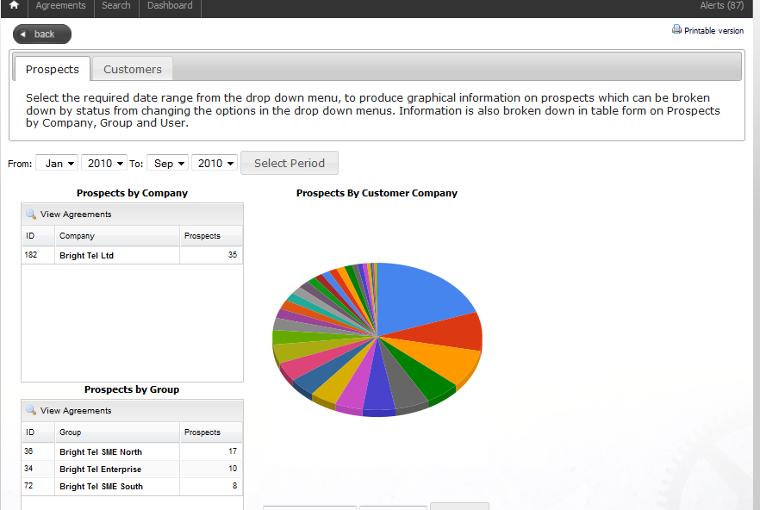

3. From the date range at the top of the page, select the required date and click 

4. The data and graph presented on the page will then change as a result of the date ranges selected.

5. To view any of the information in the tables shown, highlight the required line of information and click 

6. Alternatively, double click on the required line.

# 6.1.1 Viewing Top Prospect Information in Graphical Format:

1. Go to the first drop down box underneath the graph and select the required option, as indicated below.

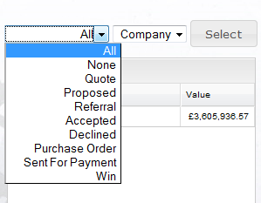

2. Select User, Group or Company from the second drop down menu box and click on the Select button.

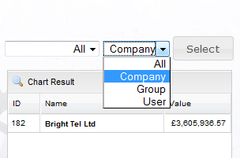

3. You will then be presented with the required information within the table below.

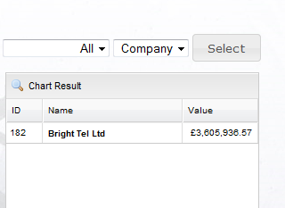

4. Highlight the individual line of information required.

5. To view the information in graphical format, click 

6. You will then be presented with the Top Prospect information as indicated below.

7. To see the legend, hover over the diagram with your mouse.

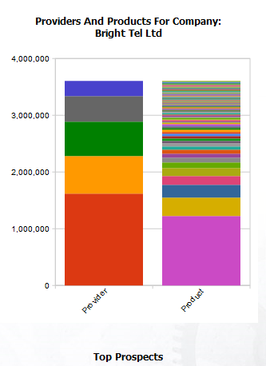

7. To View the Agreement information, highlight the line in the table below the graph and click 

8. You will then be taken to the ‘View Agreement’ screen for the selected Agreement.

# 6.2. Customers:

1. Go to  at the top left hand side of the Prospects screen within Dashboard.

2. You will then be presented with the main Dashboard screen for customers, as indicated below. This shows a snapshot of all live customer agreement information broken down by;

* **Repeat Business Opportunity by Company**
* **Repeat Business Opportunity by Group**
* **Agreements Nearing End of Term**
* **Top Repeat Business Opportunities**
* **Repeat Business Opportunity by User**

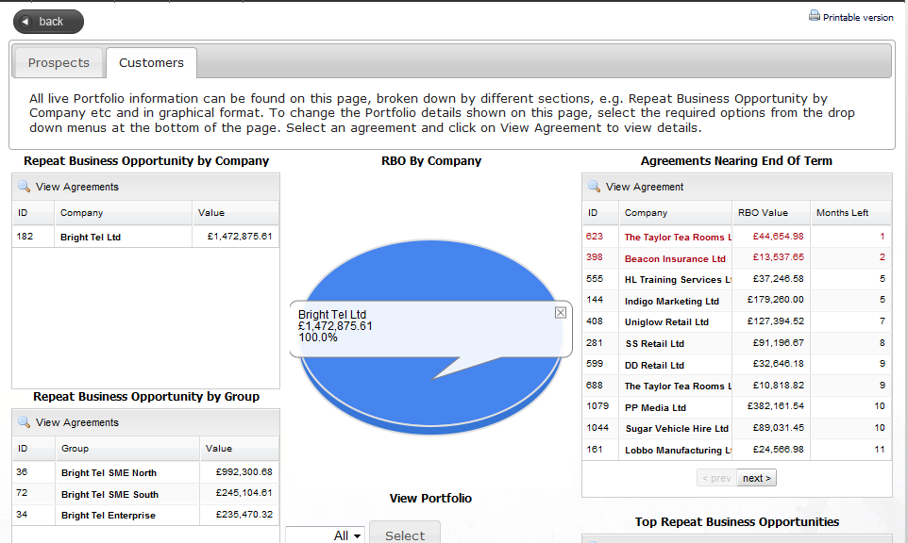

3. To view any of the individual agreement information within any of the tables as indicated above, highlight the relevant line within the table and click 

4. Dependent upon which option you select, you will then be presented with the individual Agreement Information in table format, as indicated on the following page;

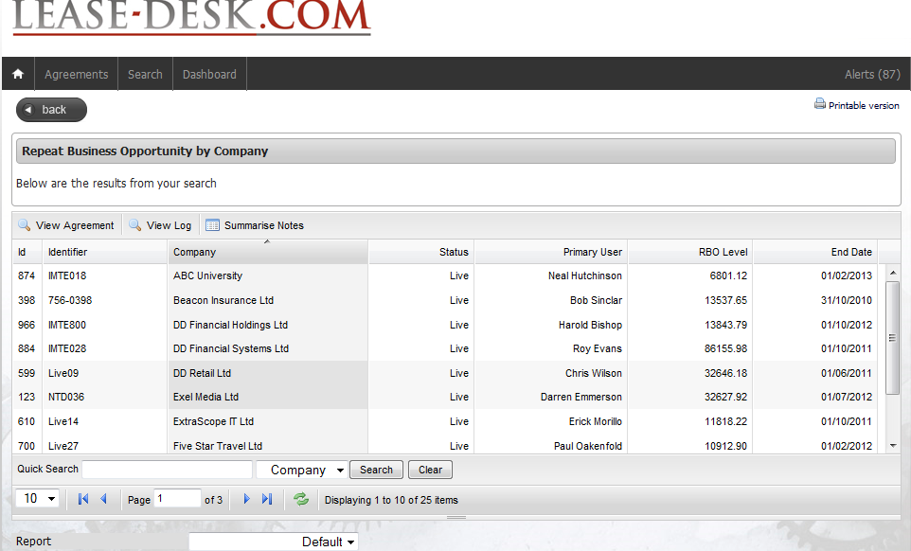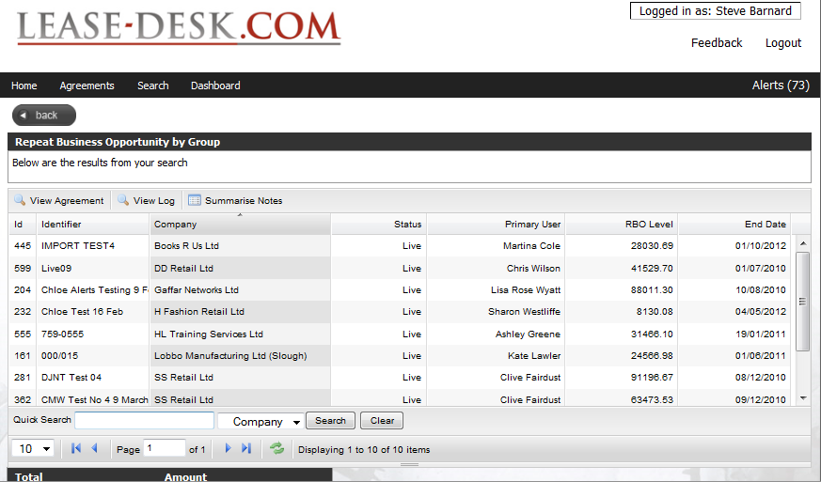

5. You then have the option to View an Agreement, View Log and Summarise Notes.

Refer back to Chapter 4 for details on how to do this.

### **6.2.1 Viewing/Amending Portfolio Information**:

1. At the bottom of the Customer Dashboard screen, go to ‘View Portfolio’ as indicated below;

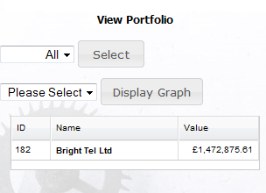

2. In the first drop down menu, select the required grouping option (Company, Group or User).

3. Click 

4. The information will then be presented in table format below.

5. Next select the Agreement grouping from the drop down menu, as indicated on the next page;

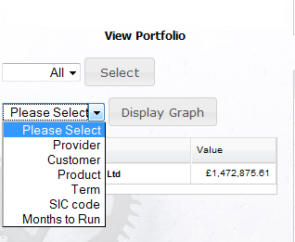

6. Highlight the required row from the table and click 

7. The information will then be shown in graphical format as indicated below;

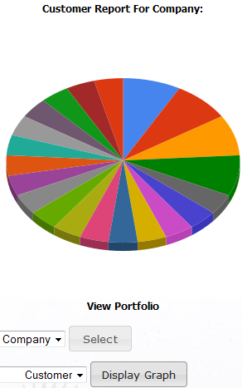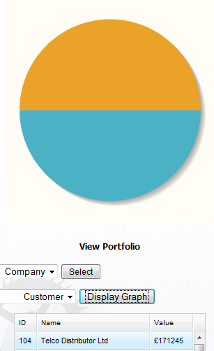

# 

# 

# 7. Alerts:

Part of Lease-Desk’s functionality is to send automatic email alerts to vendor users (Normal and Main) and administration users. As main user, dependant on your defined role, you will be able to see all of the system generated alerts associated with your viewable agreements or teams agreement information.

**Please note: The alert triggers below will also be generated to all members higher up within your organisational hierarchy that have visibility to individual or group agreement information.**

The Alert Triggers are as follows;

* When a new Agreement is added to the system as a Live, or Prospect contract.
* When a Prospect changes to a live customer (The vendor will be emailed a reminder to send over insurance details to the Financial Provider, if applicable).
* When a Prospect or Live Agreement Milestone Changes.
* When an Agreement reaches half way through its term, 12 months to run, 9 months to run, 6, 5, 4, 3, 2, and 1 month left to run.
* One month before an agreement reaches its end of term; in order to notify the customer that they need to provide written confirmation to the Financial Provider if cancelation is required.
* Monthly Live Agreement RBO values.
* When an agreement with a Minimum Period Financial Product reaches the end of term and the last payment date, and it hasn’t been manually changed, the status will change to ‘Secondary Period’ as the status. If it’s a Fixed Period, it moves to ‘End of Term’. Therefore emails and system alerts will also be generated upon Default, Secondary Period and End of Term.

**Note: *Emails generated go out on the hour and every, 15, 30, 45 minutes past the hour.***

* + - ***Alerts should appear automatically in the Alerts list.***
    - ***Alerts that are not completed will continue to generate alerts every 3 days during the following week unless the Alert has been ‘Completed’ on the system.***
    - ***If multiple agreements, whether prospect or live, for the same customer are created, the User will receive them on one email (rather than be inundated with lots of emails)***

**7.1 Viewing Alerts:**

1. To view your individual or team user alerts, select  from the top menu.

2. You will then be presented with the following ‘My Alerts’ screen as per the following page;

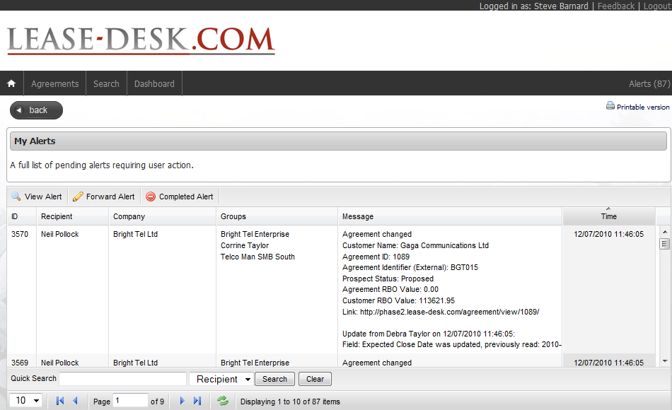

3. To view an alert, highlight the required alert and click 

4. You will then be presented with the following screen;

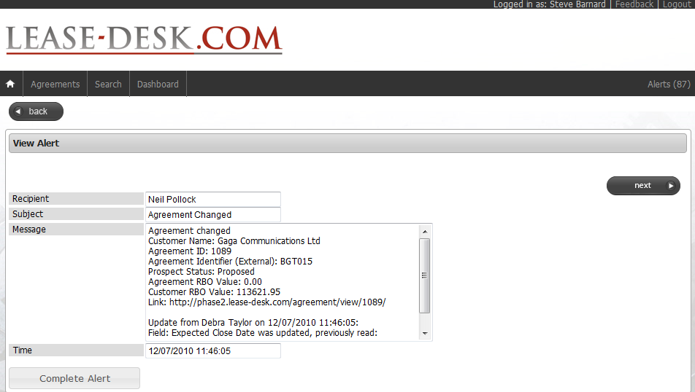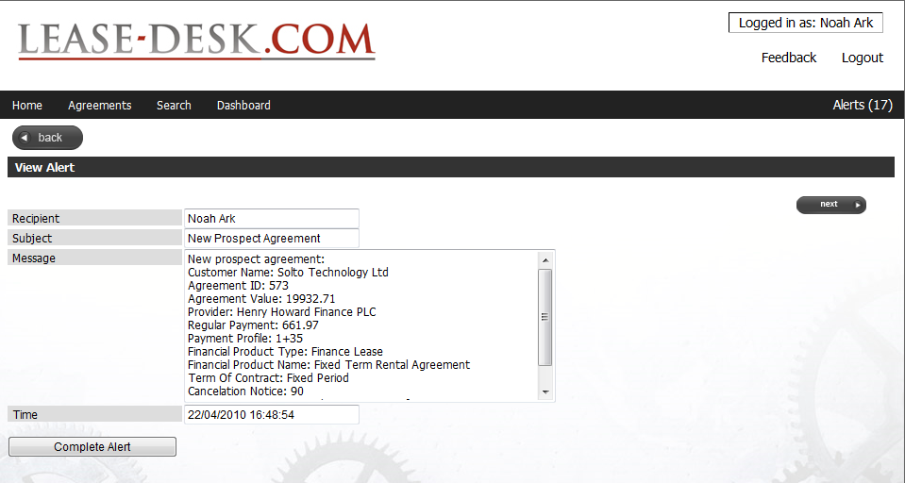

**7.2 Completing Alerts:**

1. Once the alert has been read and the action has been taken, click  from the main alert list view or from the ‘View Alert’ Screen.

**7.3 Forwarding Alerts:**

1. From the ‘My Alerts’ main view, highlight the required alert and click 

2. The alert will then be created in mail format allowing you to forward to the relevant

contact as per the following page;

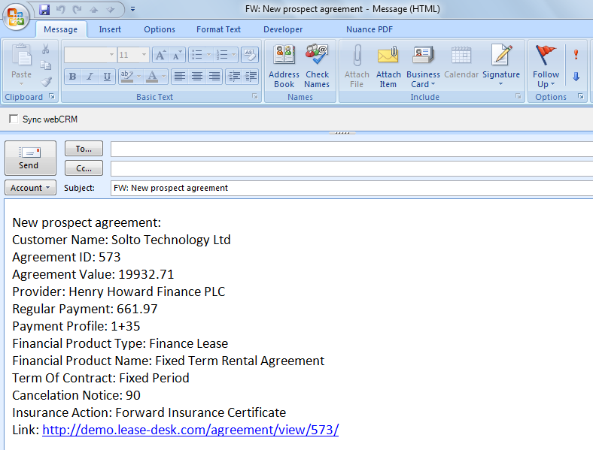

# 8. General Functionality:

# 8.1. Sort:

Within Lease-Desk, any of the main tables, for example Companies, Users, Financial Products, provide users with the ability to ‘Sort’ each column of information in alphabetical or numerical order by the column heading.

1. To sort a table using the headings of the columns to show the tables contents in alphabetical/numerical order click on the column title.

**Before Sort After Sort**

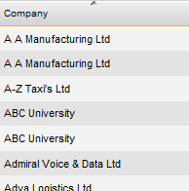

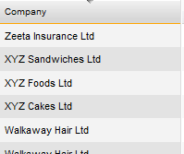

**8.2 Quick Search:**

There is a ‘Quick Search’ functionality available within the majority of the main tables (Companies, Users, and Groups etc), allowing easy access to the required information. You will find the ‘Quick Search’ function at the bottom of the tables noted above.

1. To use the quick search functionality, at the bottom of the screen, select the required option from the drop down menu (as indicated below)

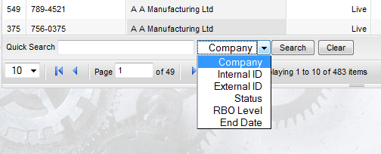

2. Enter the search information and select an option from the drop down menu as indicated above.

3. Click  to search for the information

4. Click to start from the beginning.

# 8.3 Refresh:

1. To refresh the information listed in any of the tables, select 

# 8.4 Scrolling through records:

1. To scroll forwards and backwards through any of the records listed within the tables on each screen, select the following options;

 Forward to next page of records

 Forward to end of records

 Go back to previous page of records

 Go to the start of the records

# 8.5 Changing the amount of records per view:

2. At the bottom of each table, select the drop down list to change the number or records viewed on a page at a time, as per below.

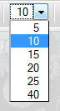

# 8.6 Last 10 Records:

1. Lease-Desk keeps a track on the last ten records that you have viewed, whether it’s an agreement or a search report. The data is stored so that you can easily go back to it at any time.

2. To access your ‘Last ten records viewed’ list, hover with your mouse over the homepage icon as per below;

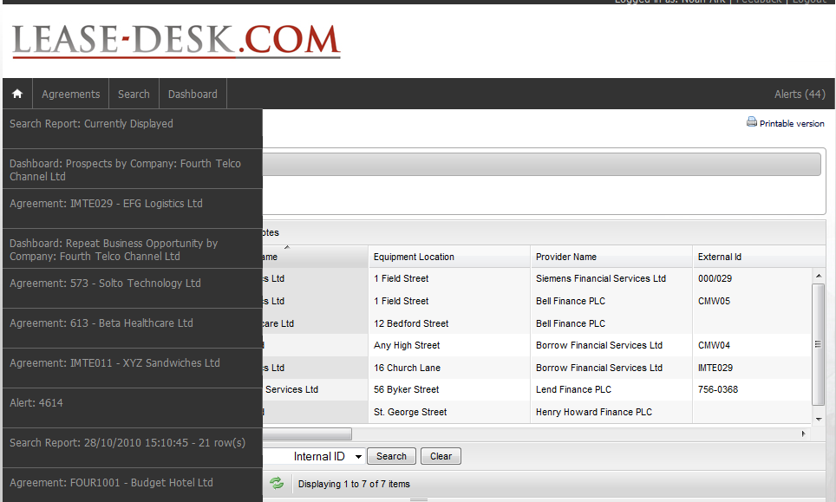

3. To go to any of the options in the dropdown list, click on the relevant item on the dropdown list.

# 

# 9. Feedback:

1. To contact Proctor Consulting’s Lease-Desk administration team with any feedback, query or issue, from the main menu select 

2. You will then be presented with the ‘Feedback Form’ screen as indicated on the following page;

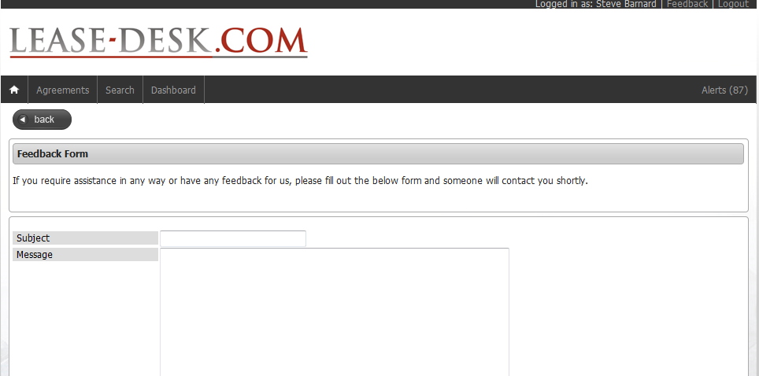

3. Add a Subject Title and complete the message detail box.

4. Once completed, click 

5. You will then be presented with the following confirmation message;



6. An email will then get sent to the Administration Team, and someone will contact you in due course.

# 10. Frequently Asked Questions:

**1. I have forgotten my login details, what do I need to do?**

Email Proctor Consulting at [support@lease-desk.com](mailto:support@lease-desk.com) or contact us via telephone on 01302

245310 and we will reset your password for you and answer any questions you may have.

**2. Why are the agreements with 3 or less months left highlighted in red on the Customer**

**Dashboard?**

This is to provide additional identification of the agreements nearing the end of term that

Require urgent action.

**3. My company information on the home page is incorrect but I am unable to amend it, how**

**can I do this?**

Either contact Proctor Consulting at the email address or phone number above, or speak to

the person who is a ‘main’ user at your site as they will have editing rights on this page.

**4. How do I print out the notes on an agreement?**

When you go to the ‘Summarise Notes’ screen within an agreement, click on the following icon;

 to print in a suitable format. You will see this icon in other areas of the system

as well.

# 11. Contact Details:

If you require any additional Lease-Desk information please contact us at;

**Proctor Consulting UK Ltd**,

Lakeview Drive,

Sherwood Business Park,

NG15 0DT

**Switchboard:** 01302 245310

**Email:** [info@Lease-Desk.com](mailto:info@Lease-Desk.com)

[**www.Lease-Desk.com**](http://www.Lease-Desk.com)